**National University of Computer and Emerging Sciences**



Laboratory Manual 08

for

Data Structures Lab

| Course Instructor | Mr Hamad ul Qudous |
| --- | --- |
| Lab Instructor(s) | Ms. Mamoona Akbar  Ms. Humna Shabir |
| Section | BDS-3C |
| Semester | Fall 2022 |

**Department of Computer Science**

FAST-NU, Lahore, Pakistan

**Objectives:**

In this lab, students will practice:

1. Binary Search Trees

Implement a Binary Search Tree and implement the functions described in each task.

**Task 1:**

Implement a recursive function which should insert nodes in BST considering the following rules of BST:

1. All nodes of left subtree are less than the root node
2. All nodes of right subtree are more than the root node

bool insert(int d)

If the data already exists in the BST, this function simply returns false and true otherwise

**Example:** Insert 5

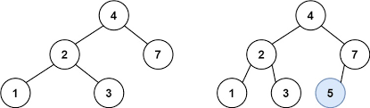

Create a function **‘Delete’** which takes a value as an argument and deletes the node containing that value.

**Task 5:**

Create a function “levelorderPrint” which prints the keys using level order traversal.

void levelorderPrint ()

**Example:**

**Output: 1 2 3 4 5 6 7 8 9 10**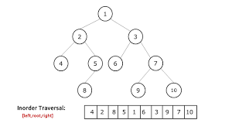

**Task 3:**

Create a function which returns the height of BST

int height()

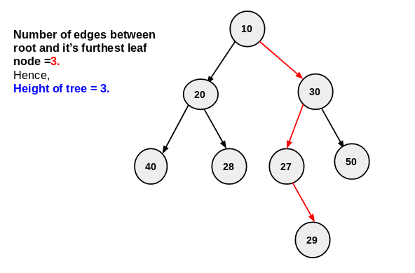

**Task 4:**

Implement a function “length” which uses recursion to return the count of total nodes in BST

int length() const

**Task 2:**

**Create the following functions:**

**int kthsmallestelement(int k) that takes a value k and return the k-smallest value from the tree.**

**For example:**

**output:**

**int kthlargestestelement(int k)**